Uber Supply Demand Gap Data Analysis

Introduction

This project analyzes Uber cab request data to identify gaps between rider demand and driver supply. By breaking down the data into various time slots, dates, and pickup points, we aim to discover when and where ride requests go unfulfilled. The analysis is performed using Microsoft Excel, utilizing features like filtering, pivot tables, conditional formatting, charts and also with Python EDA.

Project Overview
This multi-tool project investigates Uber ride request data to understand when and where Uber fails to meet rider demand. The analysis was conducted using:
- Excel for dashboarding and visualization
- SQL for deep querying and data slicing
- Python (Pandas + Matplotlib) for Exploratory Data Analysis (EDA)

Objective
- Clean and prepare Uber ride request data
- Identify time slots and pickup points with maximum unmet demand
- Analyze patterns in cancellations, "No Cars Available", and completions
- Generate actionable insights using visualization and queries

1. Module 1 – Data Cleaning Summary (Excel)
- No duplicate rows found
- No blank rows found
- Removed extra blank spaces using TRIM()
- All text formatted to proper case
- No negative values found
- Replaced NA in Driver ID with blank
- Split Request Timestamp → Request Date & Request Time
- Split Drop Timestamp → Drop Date & Drop Time
- Added Request Day and Drop Day
- Replaced invalid Drop Date, Drop Time, and rejected days with blank
- Added Request Hour, Drop Hour, and Request Time Slot for time-of-day categorization

2. Module 2 – Excel Dashboard Insights
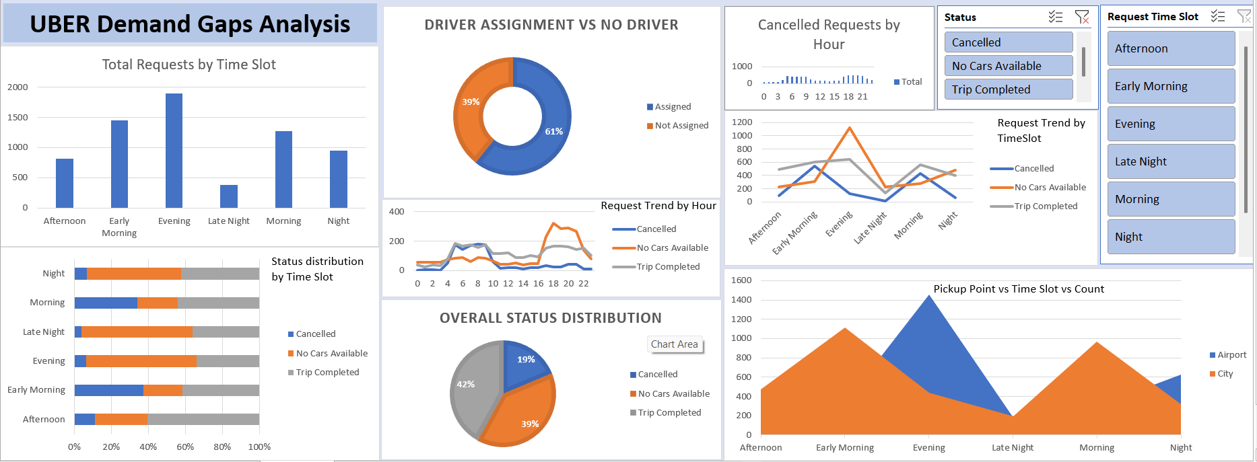
Charts used: Stacked bar charts, Pie charts, Time slot trend lines, Pivot slicers for filtering by status & time slot.

Key Insights and Observations:

1. Evening Time Slot Has Maximum Demand
Evening (5 PM to 9 PM) shows the highest number of ride requests.
However, it also suffers from a high rate of unfulfilled rides (No Cars Available or Cancelled).

2. Early Morning & Late-Night Show Supply Gaps
Early Morning (4 AM – 7 AM) and Late Night (9 PM – 12 AM) time slots have:
Fewer completed trips
Higher "No Cars Available" incidents
Indicates driver unavailability during off-peak hours.

3. Driver Assignment Gap
39% of total requests had no driver assigned, indicating a major supply deficiency.
This directly contributes to trip failures.

4. Status Breakdown
Only 42% of total requests are successfully completed.
Remaining:
19% Cancelled
39% No Cars Available
Nearly 4 out of 10 customers are not serviced.

5. High Cancellations in Morning and Early Morning Hours
Most cancellations occur between 7 AM and 10 AM could be due to:
Driver reluctance during rush hour
Traffic congestion in city areas

6. Airport Requests Fail More at Night
Airport pickup point suffers more during Night and Late-Night slots.
Many requests remain unserved due to fewer return trip opportunities or distant drop-offs.

7. City Pickup Point Has Higher Cancellations
Compared to the Airport, the City location shows a higher cancellation rate.
Possibly because of:
Traffic delays
Short-distance trip refusals

8. Trip Completion Trends Dip During Night
Across all time slots, completion rate is lowest at Night and Early Morning.
Highlights an urgent need for better driver allocation in those slots.

3. Module 3 – SQL-Based Deep Insights

Key Insights and Observations:
- Time Slot Gap Analysis - Highest gaps in Evening, Early Morning, and Late Night
- Completion Rate by Pickup - City: 43%, Airport: 41%
- Peak Failure Combinations - Evening–Airport and Night–Airport have highest failure
- Driver Utilization - Many drivers complete <50% of their assigned requests
- Hourly Status Trends - 5–9 AM are most problematic
- Lost Trips Per Slot - Evening lost >1000 trips due to no cars/cancellations

4. Module 4 – Python EDA

Key Insights from the EDA
The analysis revealed several critical insights about the Uber supply-demand gap:
- High Failure Rate: A significant proportion of ride requests are failing (either cancelled or 'No Cars Available'), indicating a major service delivery issue.
- Peak Demand Hours: Demand is highest during typical peak hours (Early Morning, Morning, Evening, Night).
- Time-Based Supply Issues: 'No Cars Available' is a major problem during Late Night and Early Morning hours. This points to a severe driver shortage during these times.
- Cancellations are particularly high during the Early Morning hours. This suggests drivers might be canceling trips (perhaps shorter ones or those going to destinations they don't want to serve, like the airport).
- Location-Based Issues: Airport pickups suffer significantly from 'No Cars Available'. This is a critical bottleneck, likely due to drivers not wanting to make the trip or return from the airport.
- City pickups have more cancellations than 'No Cars Available', suggesting different issues compared to the airport.
- Weekday Trends: While daily request volume is relatively consistent, weekdays (especially Monday and Tuesday) seem to have slightly higher failed requests compared to weekends.
- Successful Operating Windows: Trip completion is highest during morning and evening rush hours where, despite high demand, supply seems relatively better balanced compared to other periods.

These insights directly highlight the specific times and locations where Uber needs to focus its efforts to improve driver availability and reduce trip failures.

Chart - 1: Distribution of Ride Requests by Status
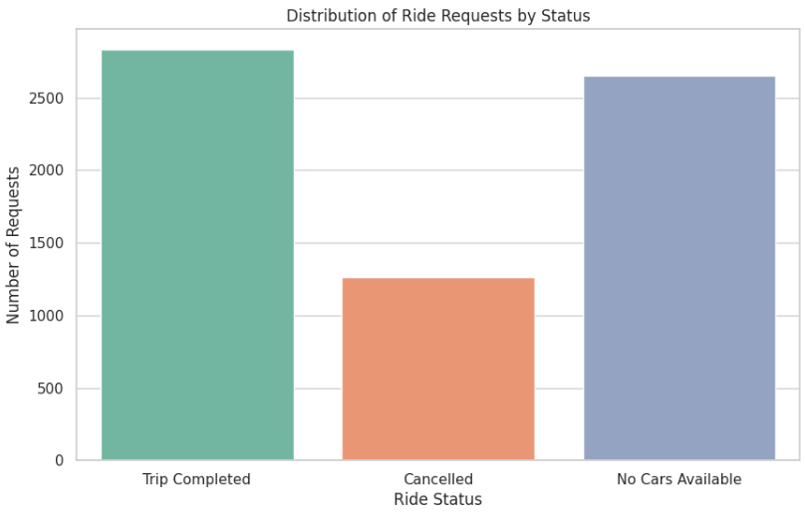
Insight: A significant portion of ride requests were not completed, either due to cancellation or no cars being available. The number of failed requests is nearly equal to the number of completed trips.
Observation: This immediately indicates a major problem with Uber's ability to fulfill demand.

Chart - 2: Requests by Pickup Point
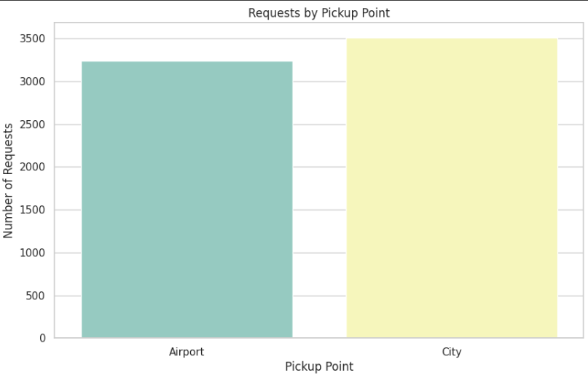
Insight: More ride requests originate from the City compared to the Airport.
Observation: The City is the primary source of ride demand in this dataset.

Chart - 3: Ride Requests by Hour of the Day
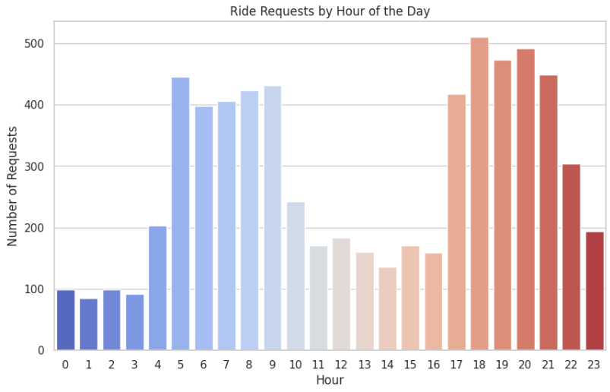
Insight: Peak demand occurs during the typical rush hours: early morning (around 5 AM - 10 AM) and evening (around 5 PM - 9 PM).
Observation: Uber experiences significant fluctuations in demand throughout the day.

Chart - 4: Status of Requests by Hour
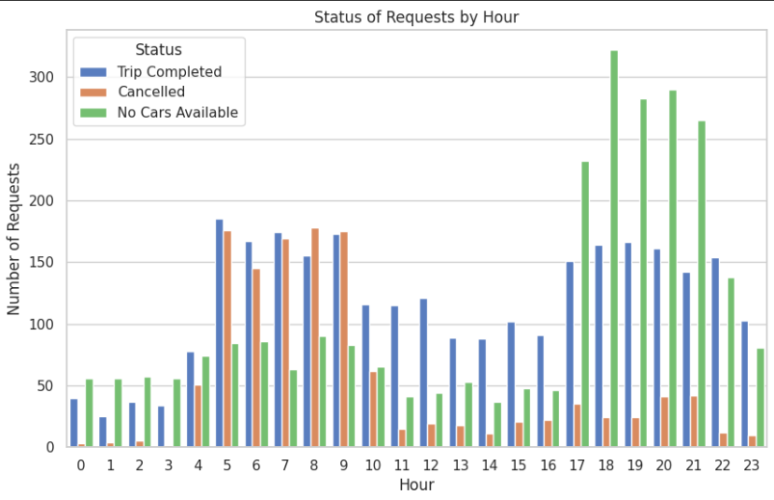
Insight: The 'No Cars Available' status is most prevalent during late night and early morning hours. Cancellations are also high during the early morning peak.
Observation: The supply-demand gap is most pronounced during these specific times.

Chart - 5: Ride Status by Pickup Point (City vs Airport)
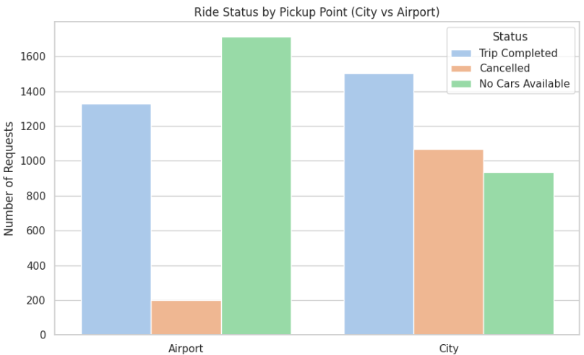
Insight: Airport pickups have a disproportionately high number of 'No Cars Available' requests compared to City pickups.
Observation: Drivers may be less willing to go to the airport, or there might be a shortage of drivers available at the airport at certain times.

Chart - 6: Ride Requests by Time Slot
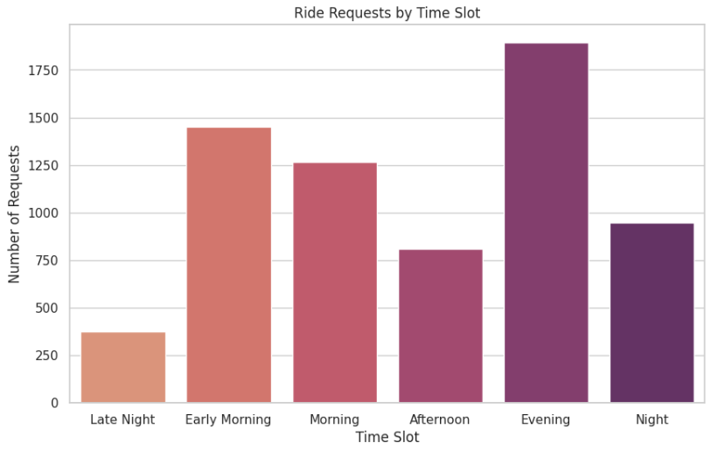
Insight: The 'Morning' and 'Evening' time slots have the highest overall ride request volumes.
Observation: This confirms the peak demand identified in the hourly analysis, grouped into broader categories.

Chart - 7: Status of Requests by Time Slot
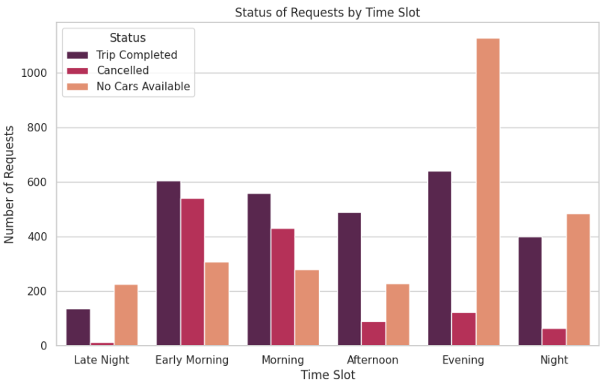
Insight: 'No Cars Available' is a major issue during the 'Night' and 'Early Morning' time slots. Cancellations are also significant during 'Early Morning'.
Observation: These specific time slots require urgent attention to address the supply gap.

Chart - 8: Total Requests per Day
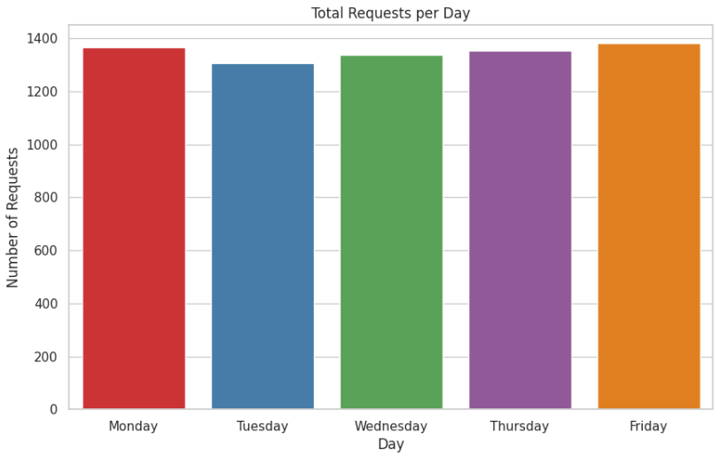
Insight: The number of requests is relatively consistent across weekdays, with a slight decrease on weekends.
Observation: Demand is fairly stable throughout the week, suggesting the supply issues are not necessarily tied to specific days of the week but rather times of the day and locations.

Chart - 9: Status of Requests by Day
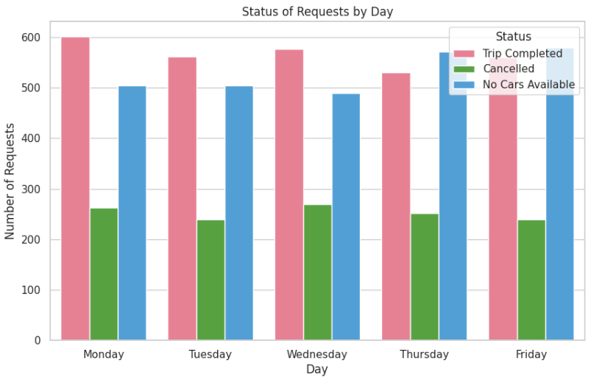
Insight: Weekdays, particularly Monday and Tuesday, show slightly higher numbers of failed requests (both cancelled and no cars available).
Observation: While demand is consistent, the service failures might be slightly more frequent at the start of the week.

Chart - 10: No Cars Available by Hour
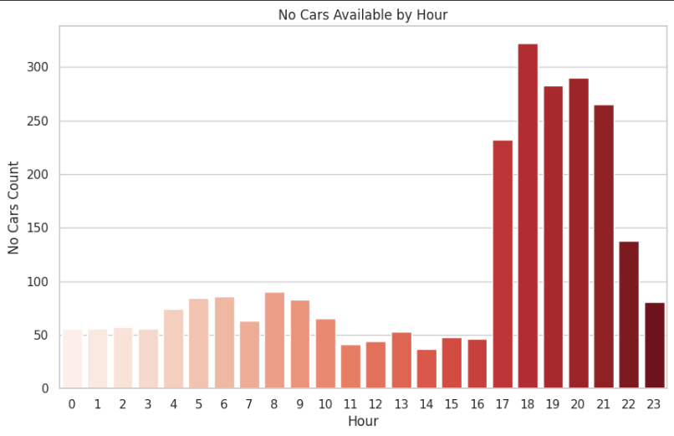
Insight: The peak for 'No Cars Available' is clearly concentrated in the early morning hours (roughly 12 AM to 6 AM).
Observation: This strongly indicates a driver shortage during overnight and early morning hours.

Chart - 11: Cancelled Requests by Hour
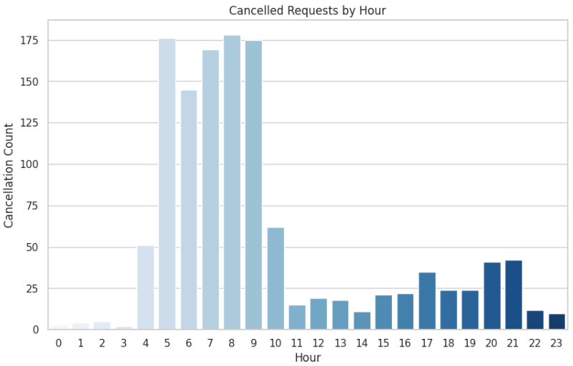
Insight: Cancellations are highest during the morning rush hour, from around 4 AM to 9 AM.
Observation: This suggests drivers might be cancelling trips during this time, possibly due to unfavorable destinations (like early morning airport drop-offs) or other factors.

Chart - 12: Completed Trips by Hour
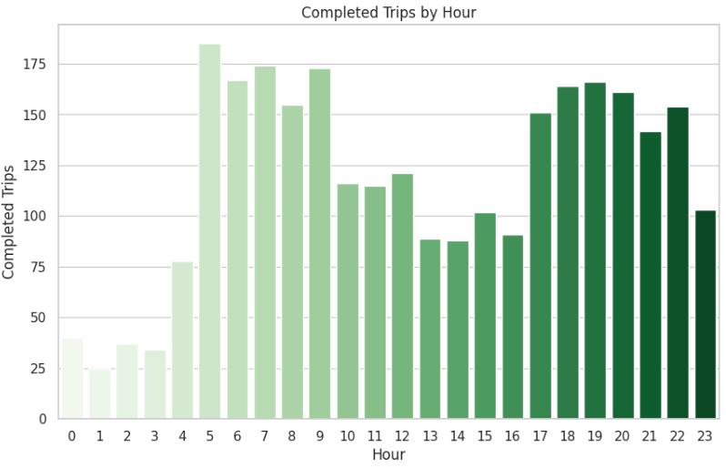
Insight: Uber is most successful in completing trips during the main business hours (8 AM - 10 AM and 6 PM - 9 PM).
Observation: These hours likely have a better balance of driver supply and customer demand.

Chart - 13: Completed Trips by Time Slot
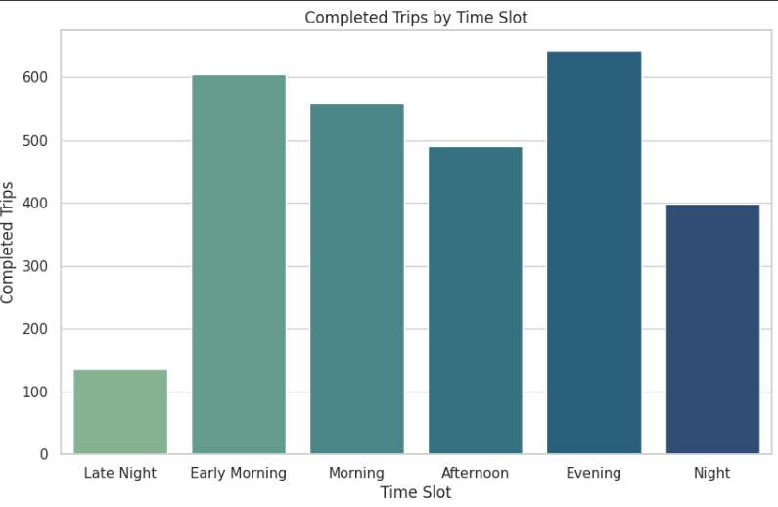
Insight: The 'Morning' and 'Evening' time slots have the highest number of completed trips.
Observation: This reinforces that Uber's operations are most effective during these peak demand periods where supply is likely better aligned.

Chart - 14: Trip Completion Rate by Day
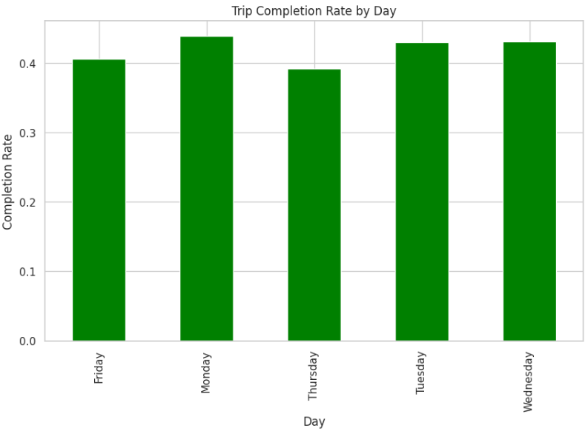
Insight: The trip completion rate is highest mid-week (Tuesday, Wednesday).
Observation: This indicates that operational efficiency is slightly better during the middle of the week.

Chart - 15: Correlation Heatmap for Numeric Columns
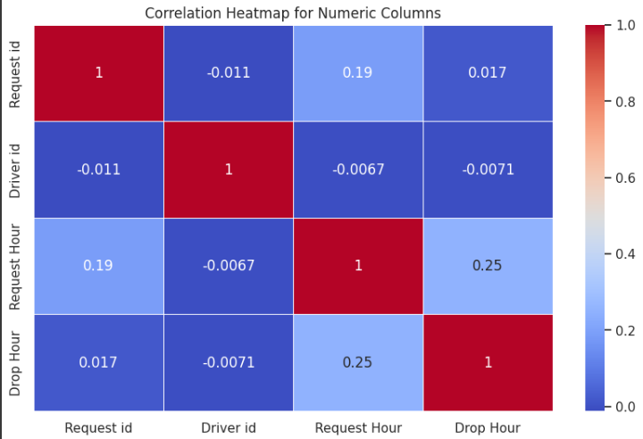
Insight: (Requires examining the heatmap) You can see the strength and direction of relationships between numerical variables. For example, Request Hour and Drop Hour are likely positively correlated.
Observation: This helps understand how numerical variables move together, though the insights here are less direct for the primary business problem compared to the categorical analyses.

Chart - 16: Pair Plot of Numeric Variables
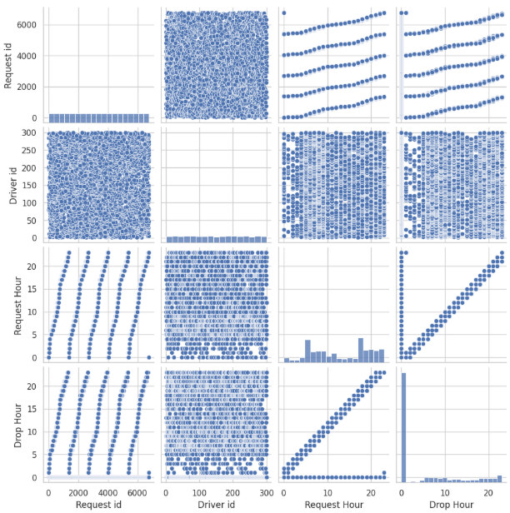
Insight: (Requires examining the pair plot) You can visually inspect the distributions of each numeric variable and their pairwise relationships. This can help spot clusters, outliers, or trends that aren't clear from the correlation heatmap.
Observation: Useful for getting a high-level view of the relationships between numeric variables and identifying potential data issues or patterns.

5. Module 5 – Final Recommendations
-- Reallocate drivers to underserved time slots (Early Morning, Late Night)
-- Add night shift cabs near Airports
-- Automate time-slot-based supply tracking system
-- Use SQL + Python for weekly performance reviews

